Batch: B2 Roll No.: 16010121200

Experiment / assignment / tutorial No.: 5

TITLE: Introduction and Exploration of Neo4J

AIM: Installation and Exploration of Neo4J
_____________________________________________________________________
Expected Outcome of Experiment:
_____________________________________________________________________
Books/ Journals/ Websites referred:
_____________________________________________________________________

Introduction Graph Analytics:
We study social networks and algorithms for their analysis. The canonical example of a social network is the graph of Facebook friends, where the nodes are people, and edges connect two people if they are friends. Directed graphs, such as followers on Twitter, can also be viewed as social networks. A common example of a problem to be addressed is identifying “communities,” that is, small sets of nodes with an unusually large number of edges among them. Other questions about social networks are general questions about graphs, such as computing the transitive closure or diameter of a graph, but are made more difficult by the size of typical networks.

Steps to perform given experiment:
- Download Neo4j.


- Install Neo4j.




- Download the dataset (*graph-based dataset …refer presentation).
- Perform following CQL
  - Create Nodes
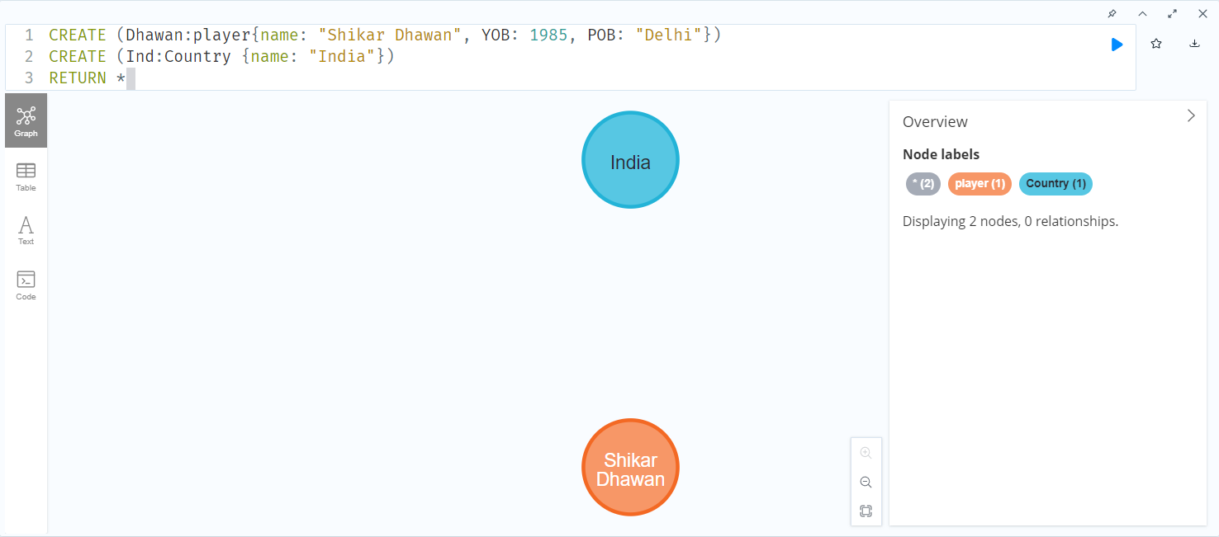
  - Creating relationships
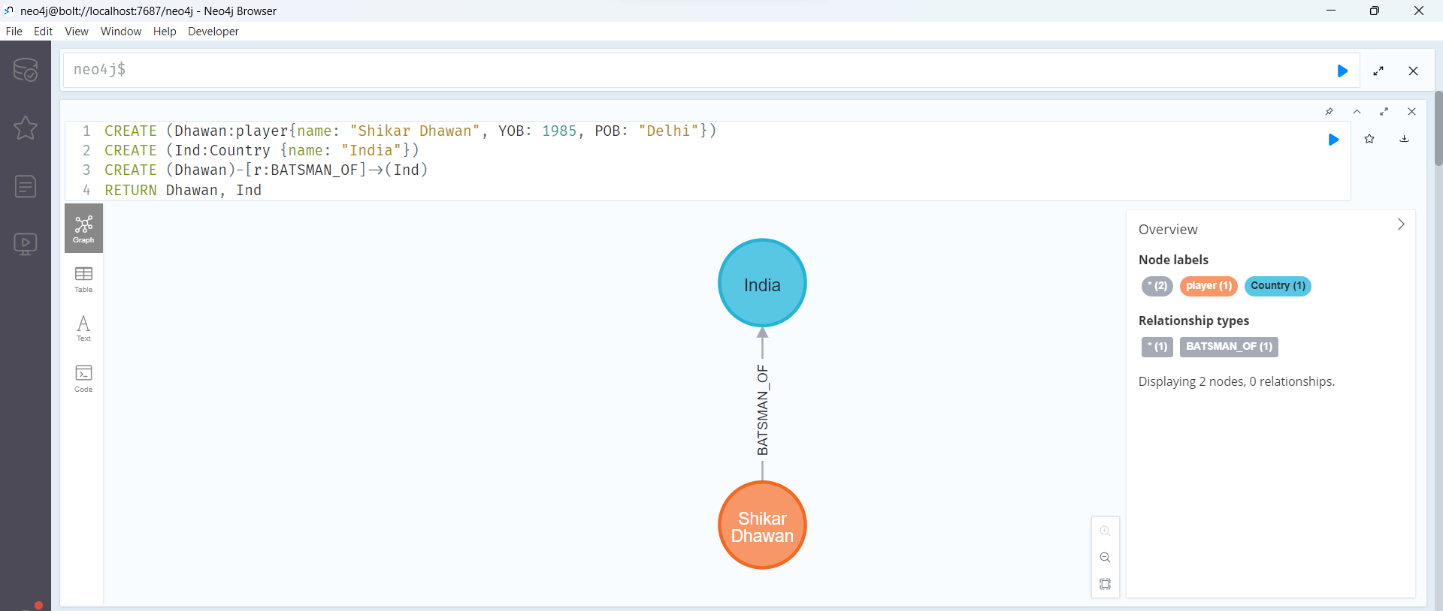

  - Merge command
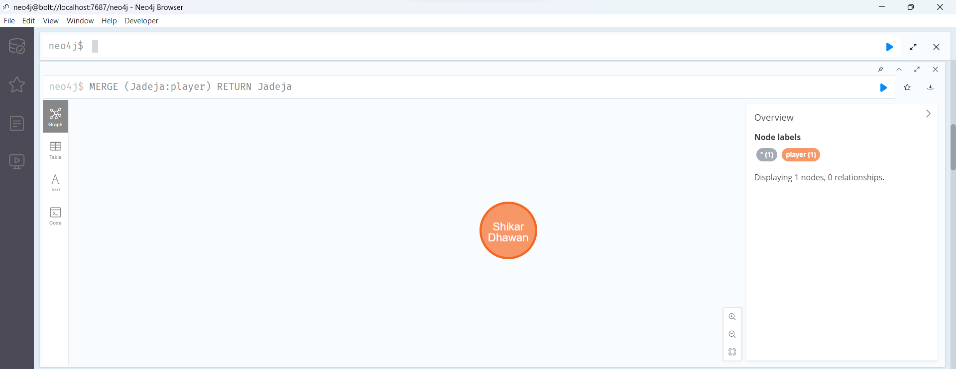
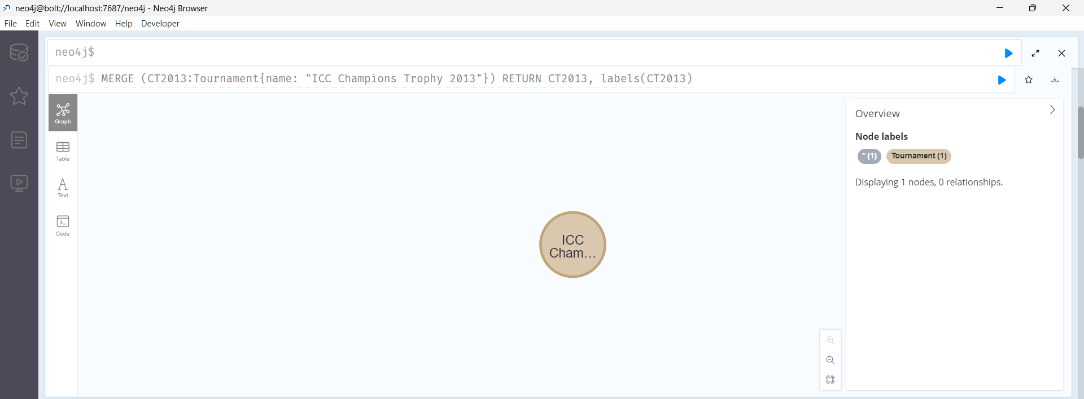
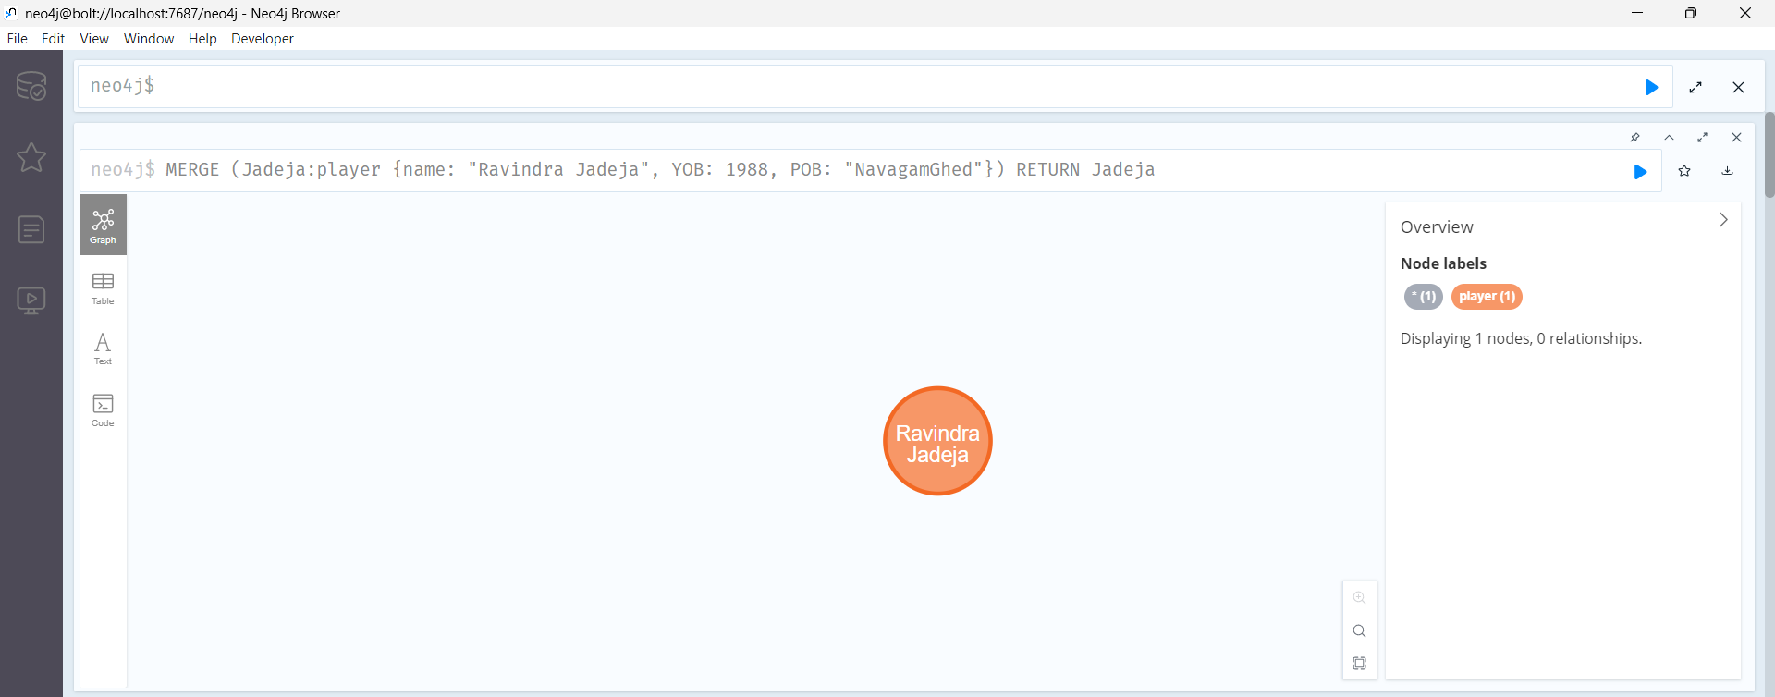
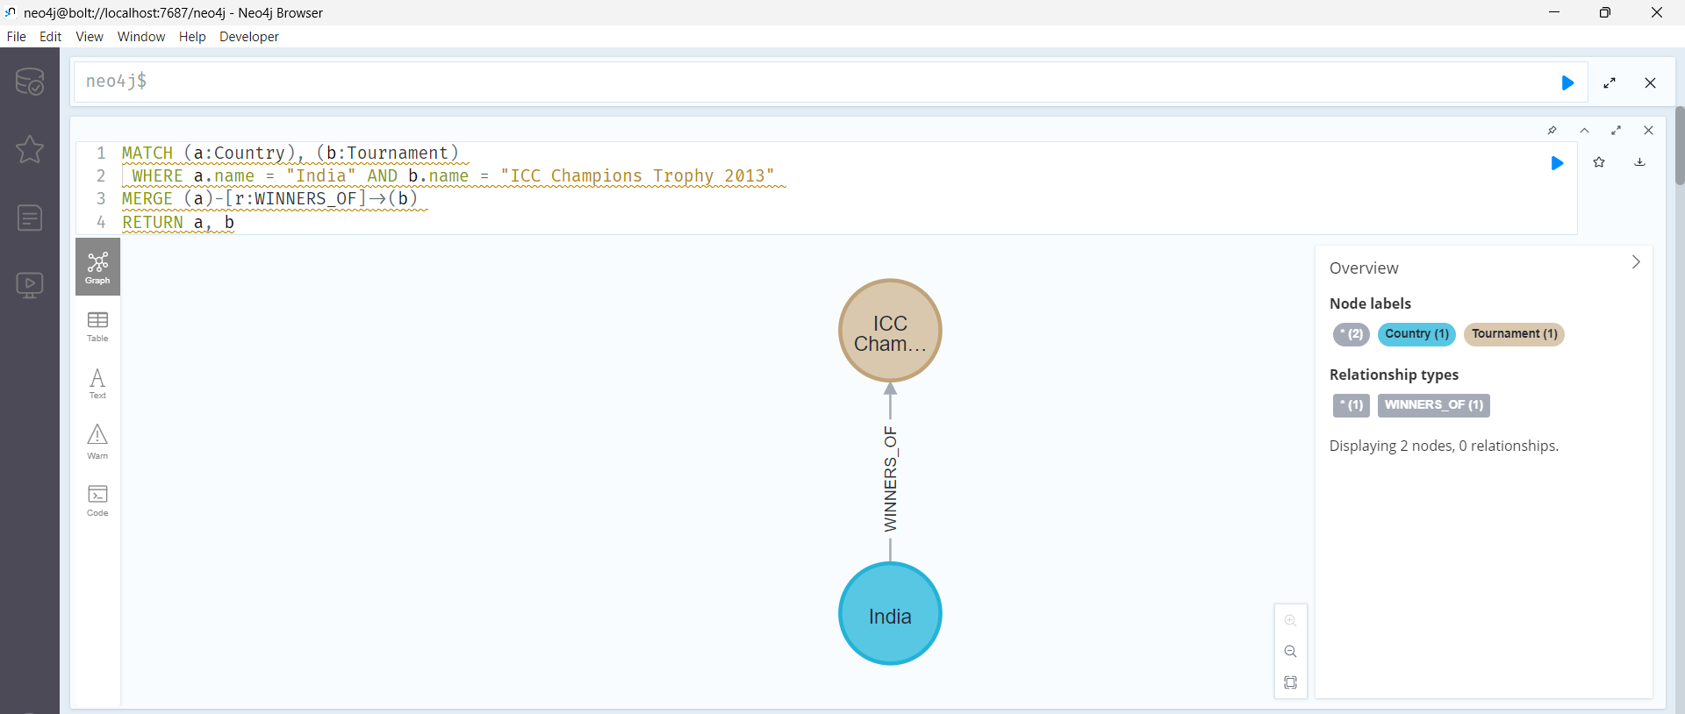
  - Set Clause
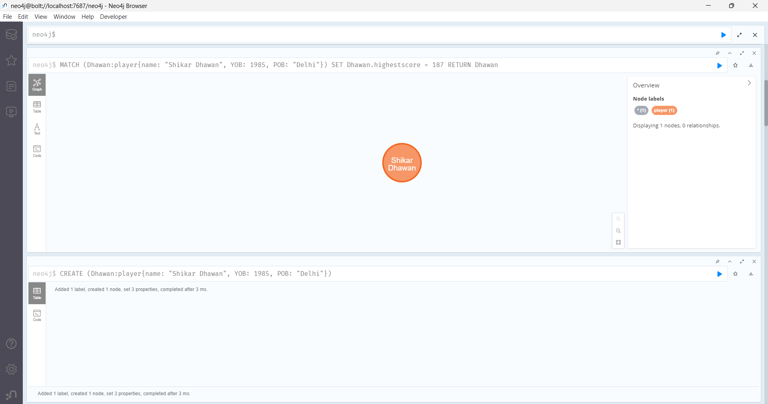
  - Delete Clause
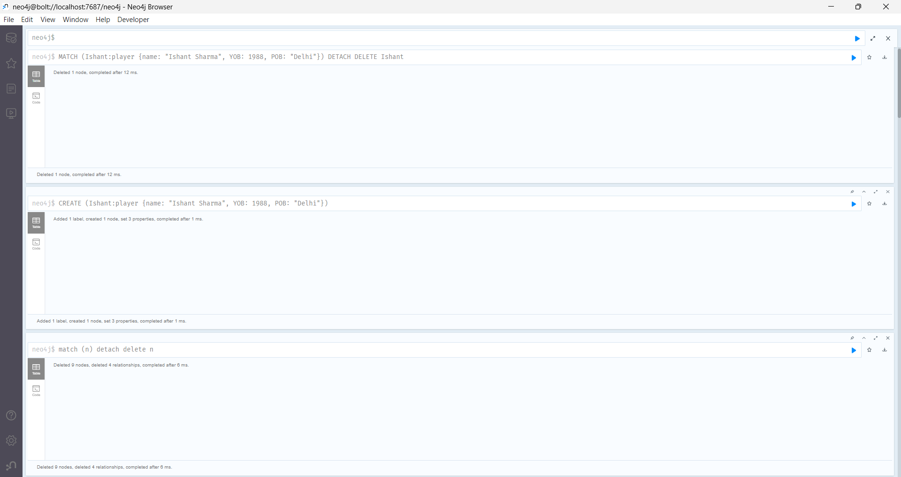
  - Remove Clause
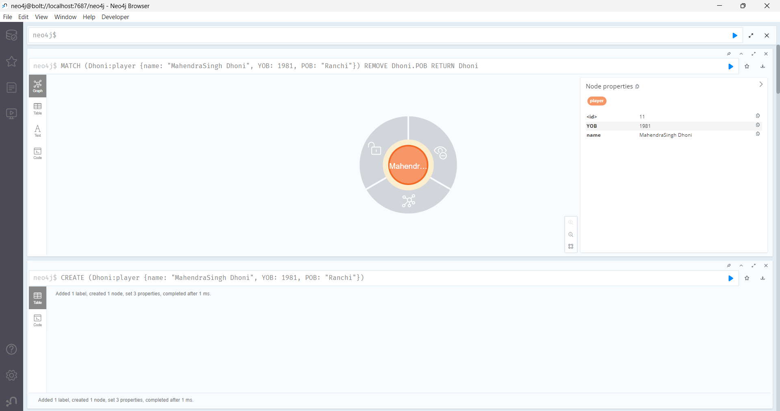
  - Foreach Clause
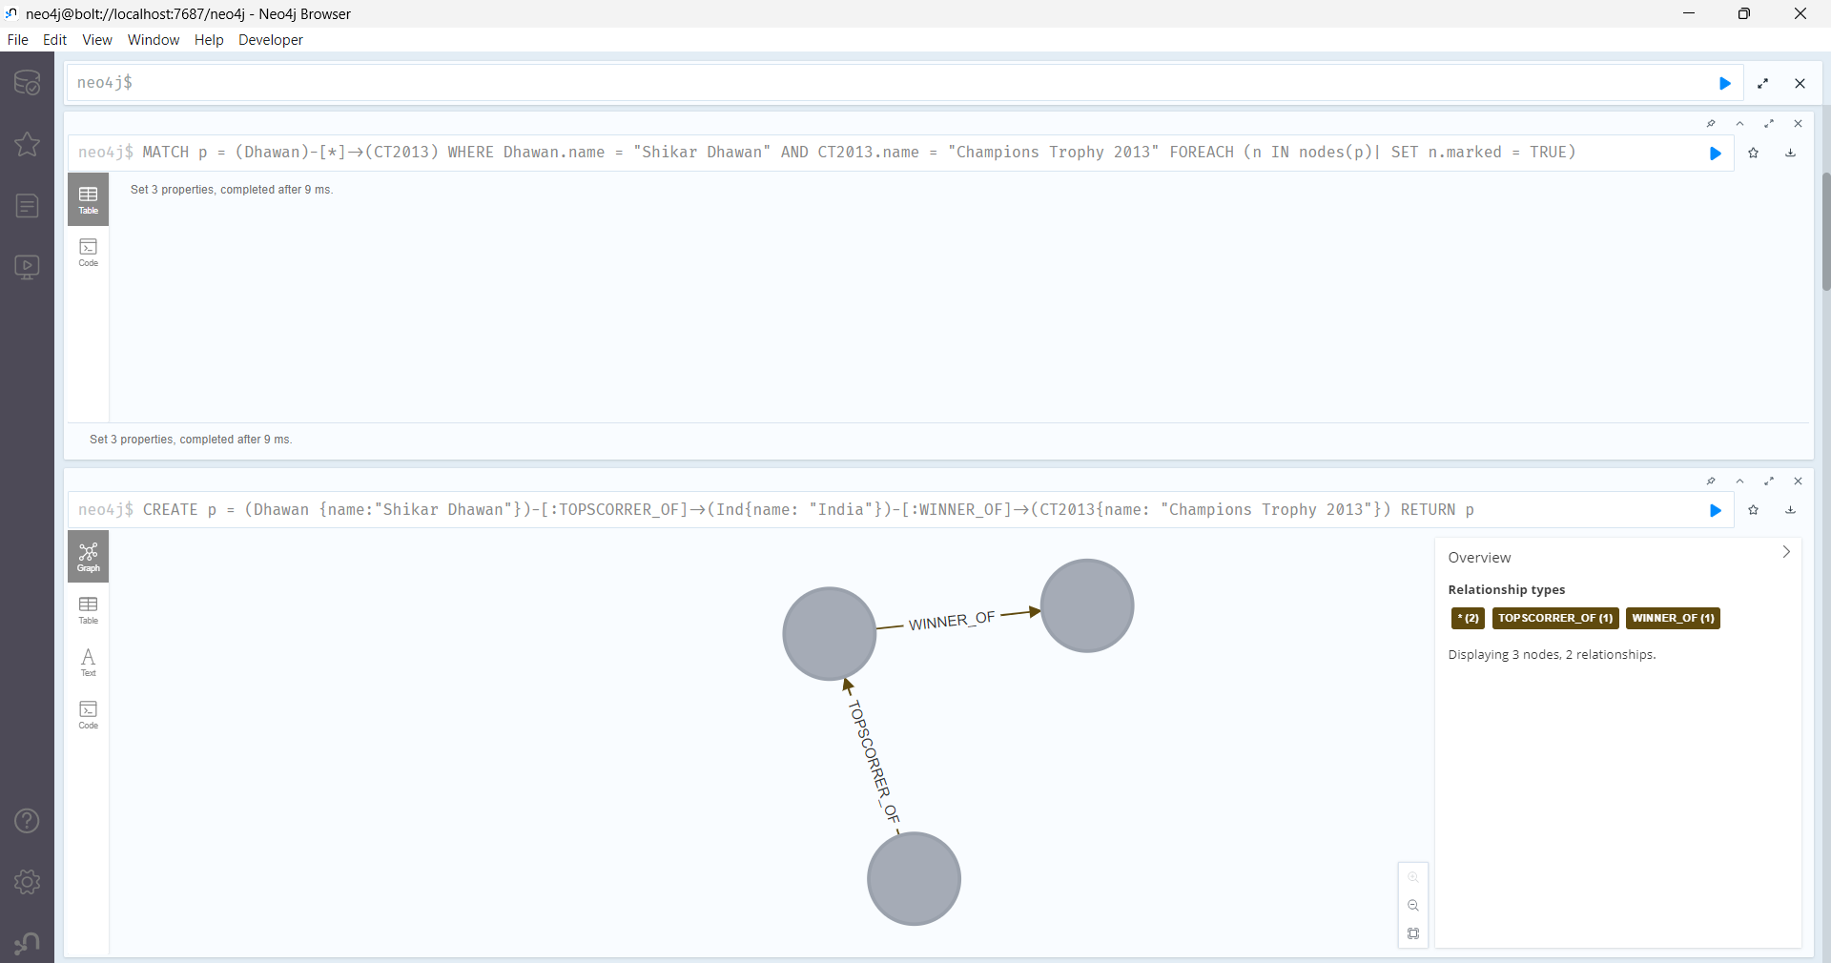

  - Match clause
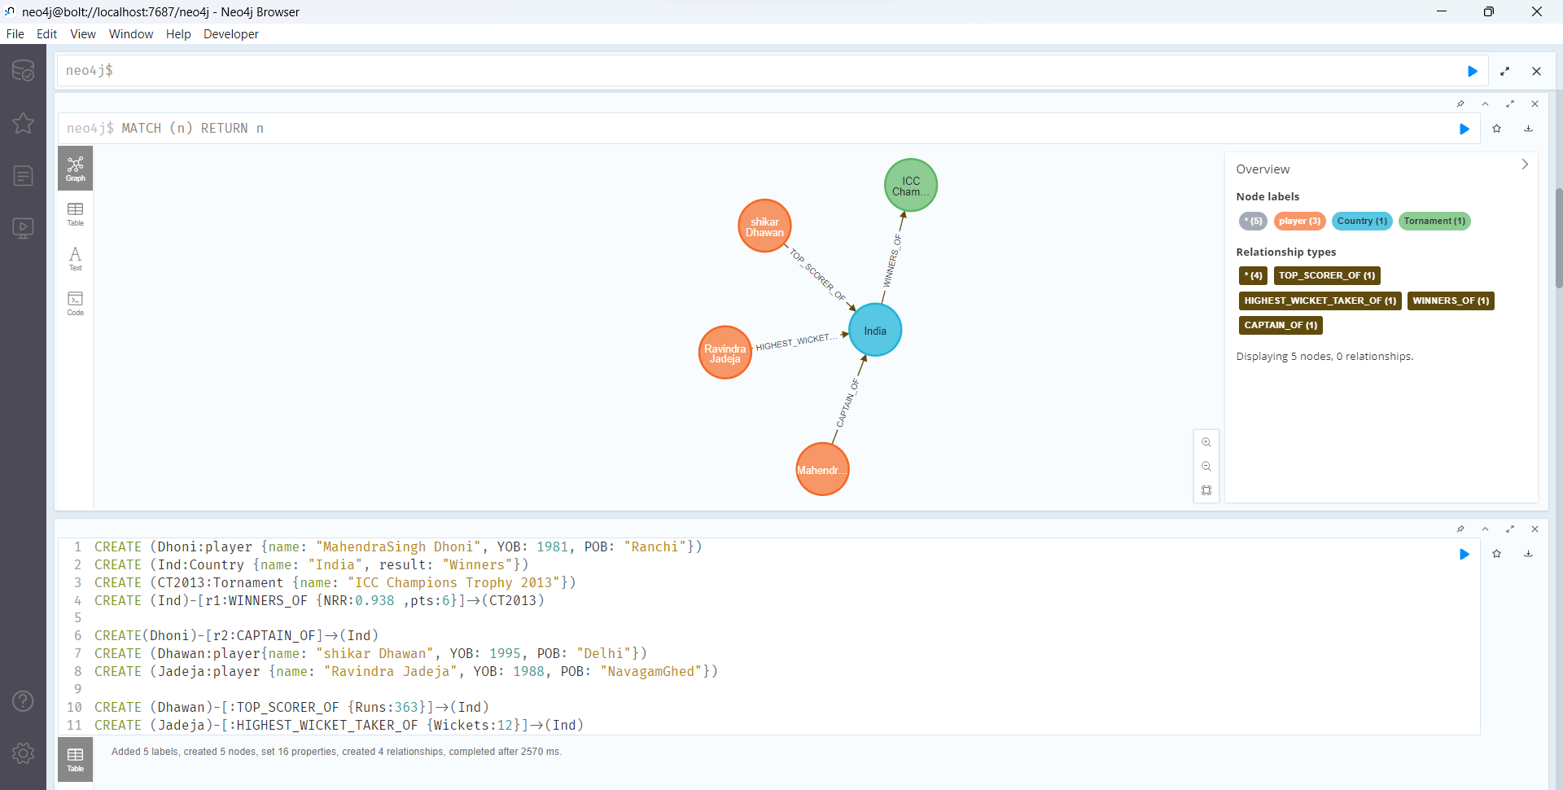
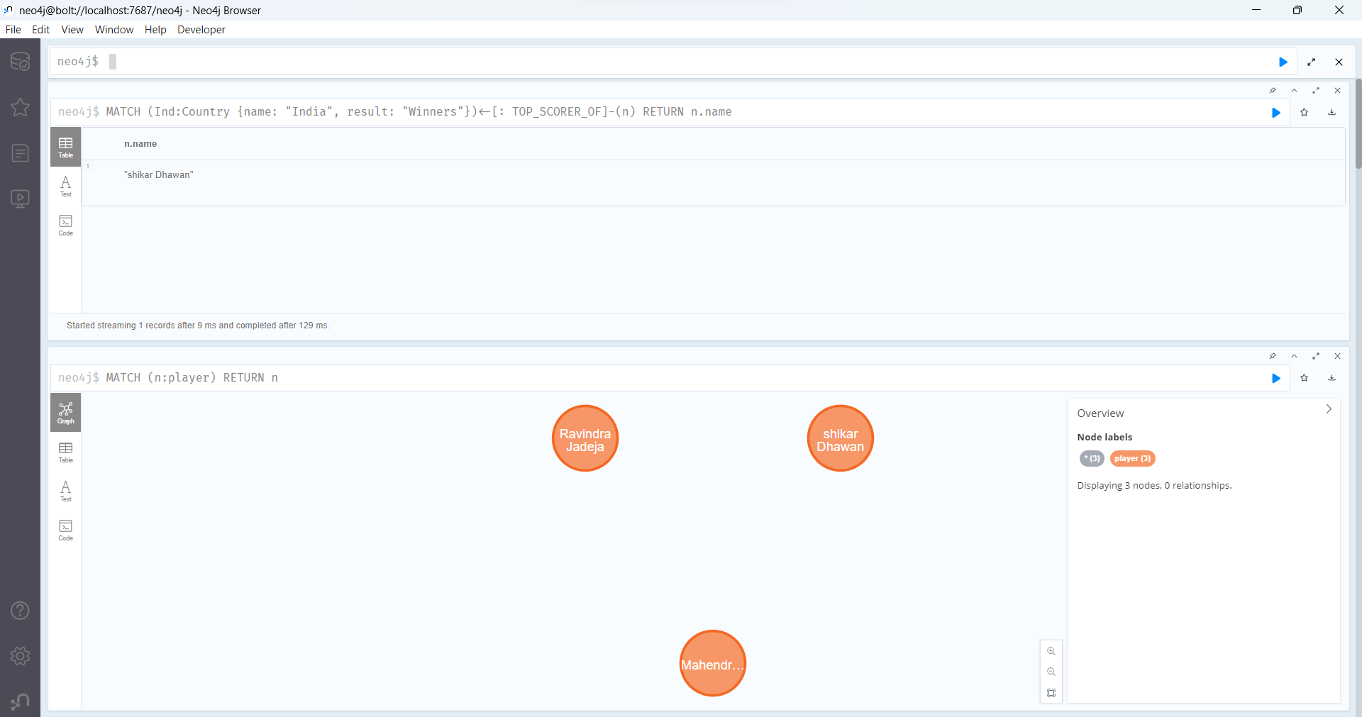

  - Where clause
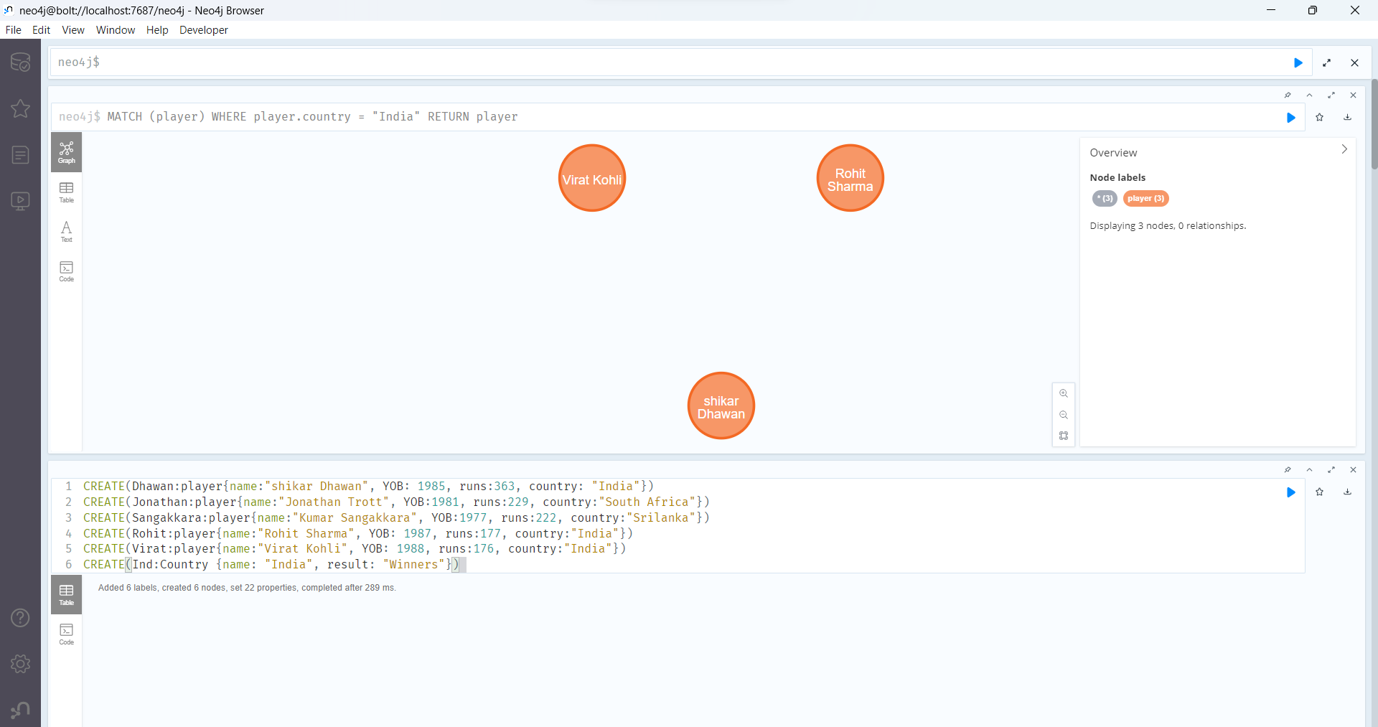
  - Count function
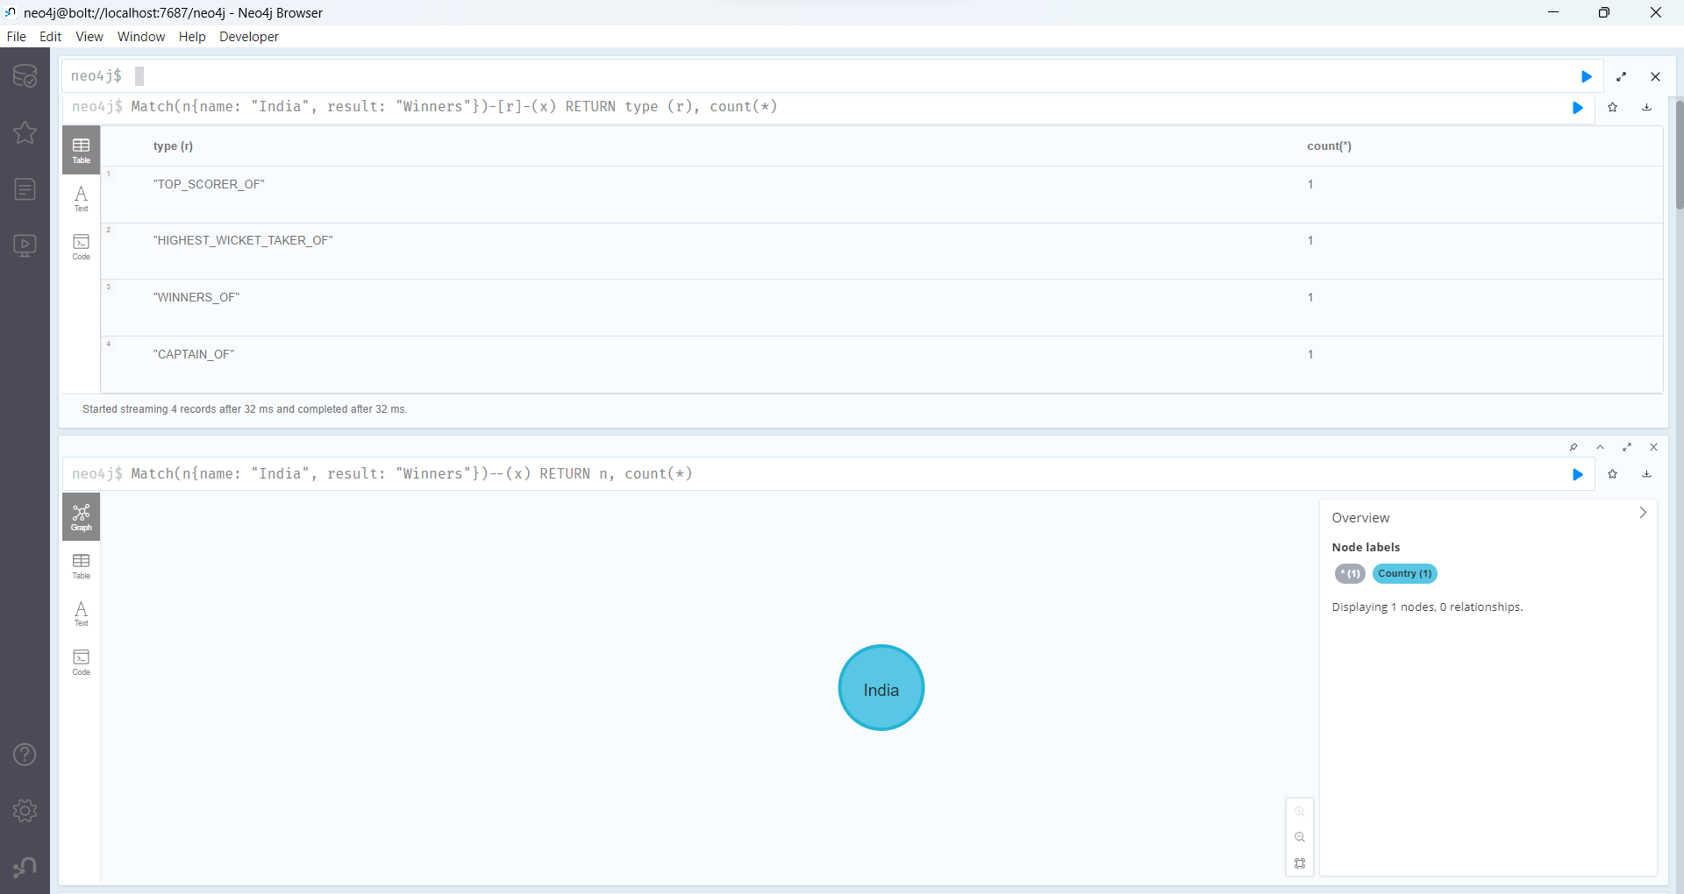

  - Return Clause
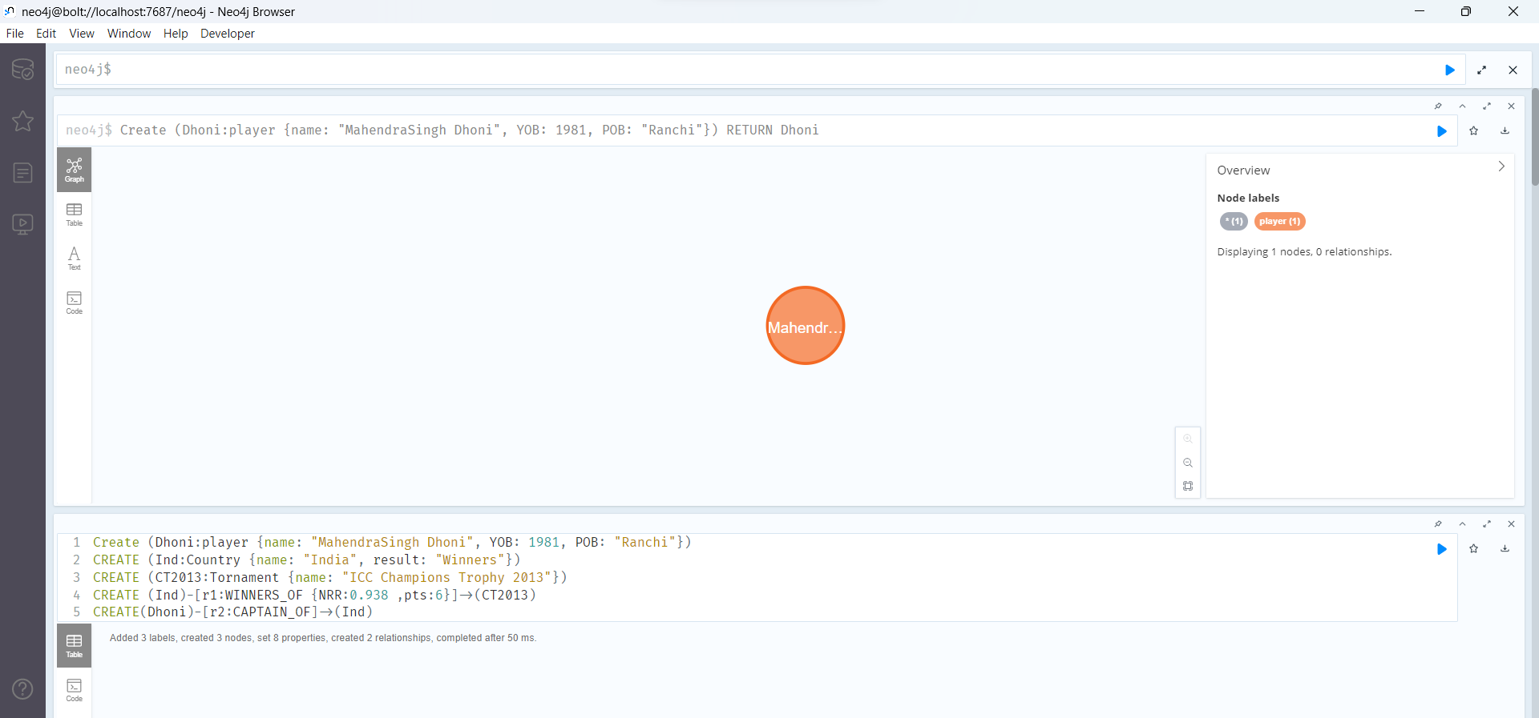
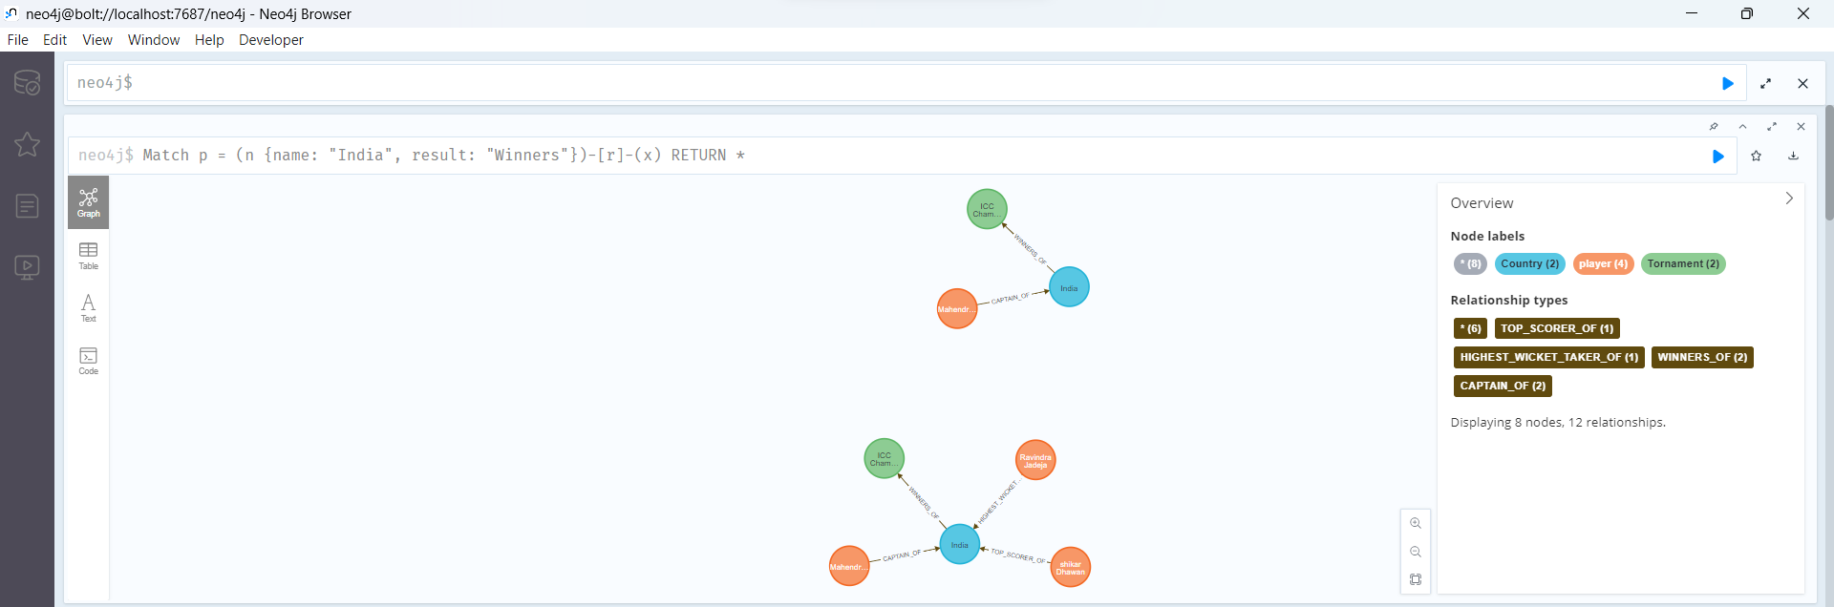
  - Order By Clause
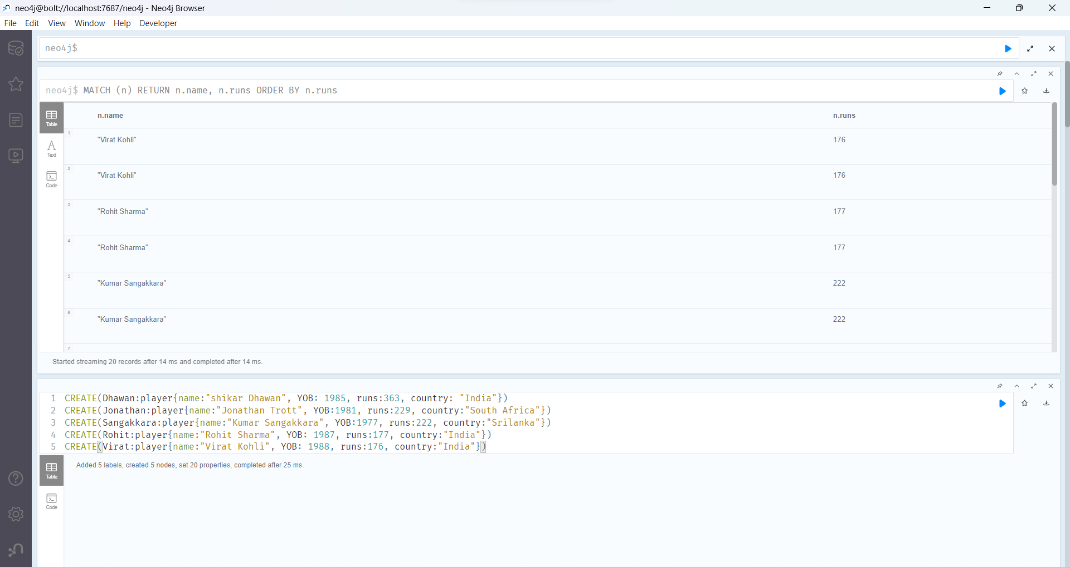
  - Search
- Import the dataset in Neo4j.
- Write a graph query over the database imported to perform analytics.

Screenshots of dataset installation
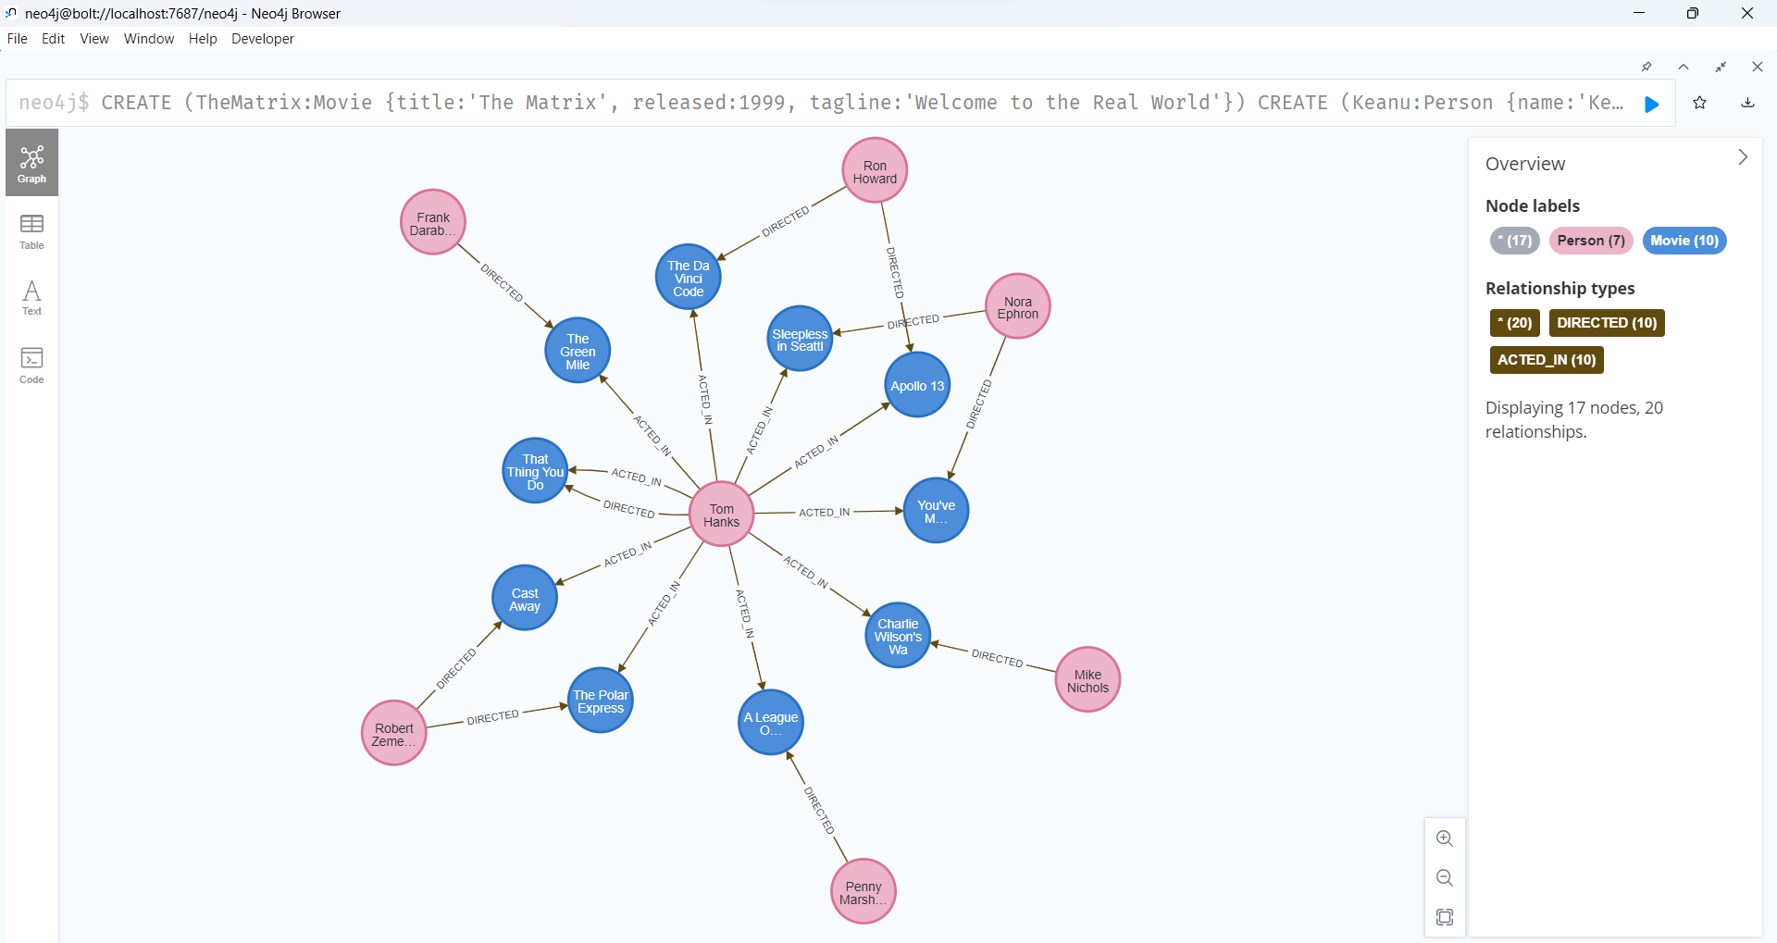

Link of Dataset:
Default Movie DBMS
C:\Users\asmit\.Neo4jDesktop\relate-data\dbmss\dbms-b2c9af6d-1c9a-4957-bb65-b1a82c760d87
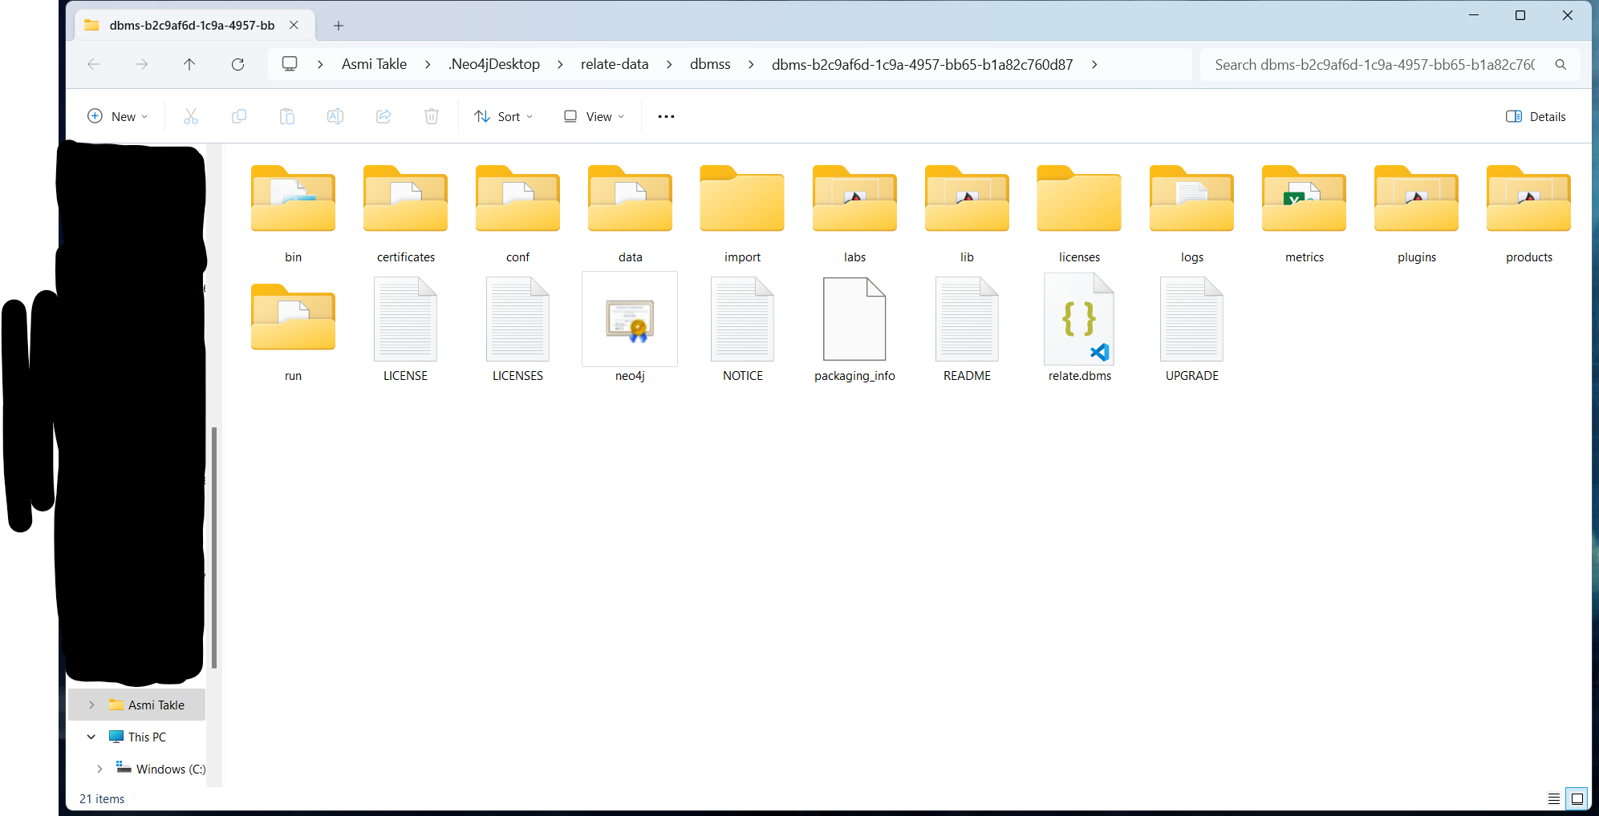
Details of dataset:
Movie dbms about actors, movies, directors, release dates, tag lines

Analysis Details with Explanation and screenshots:

Relationship between nodes:
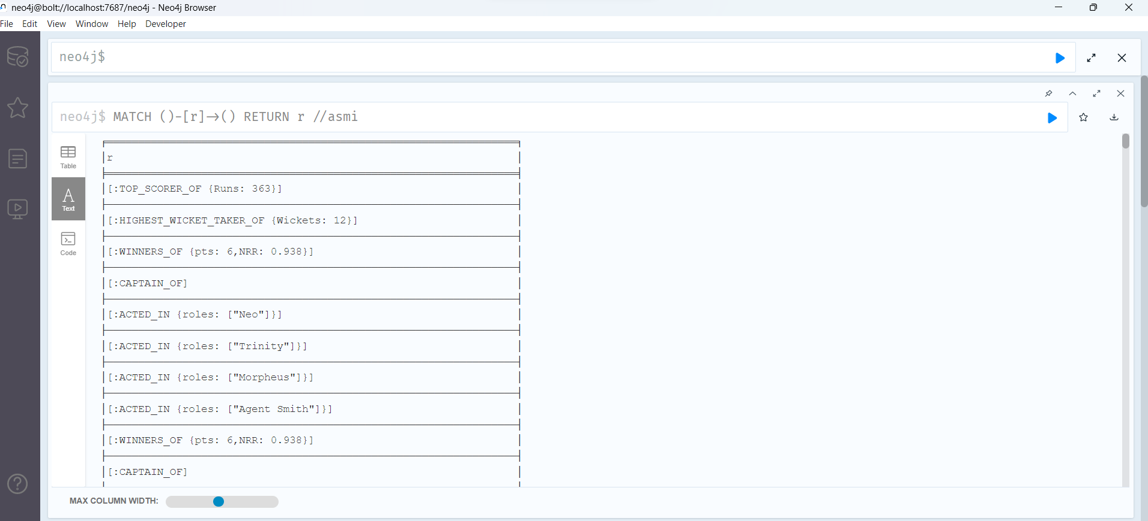

Find which actors acted in the movie ‘The Matrix’:
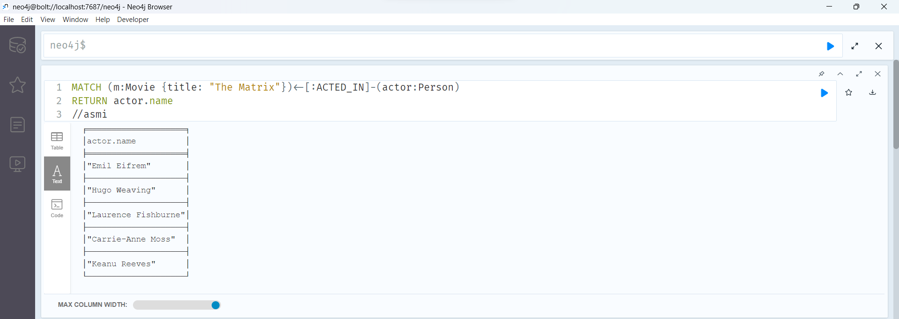

Find movies released in year 1999:
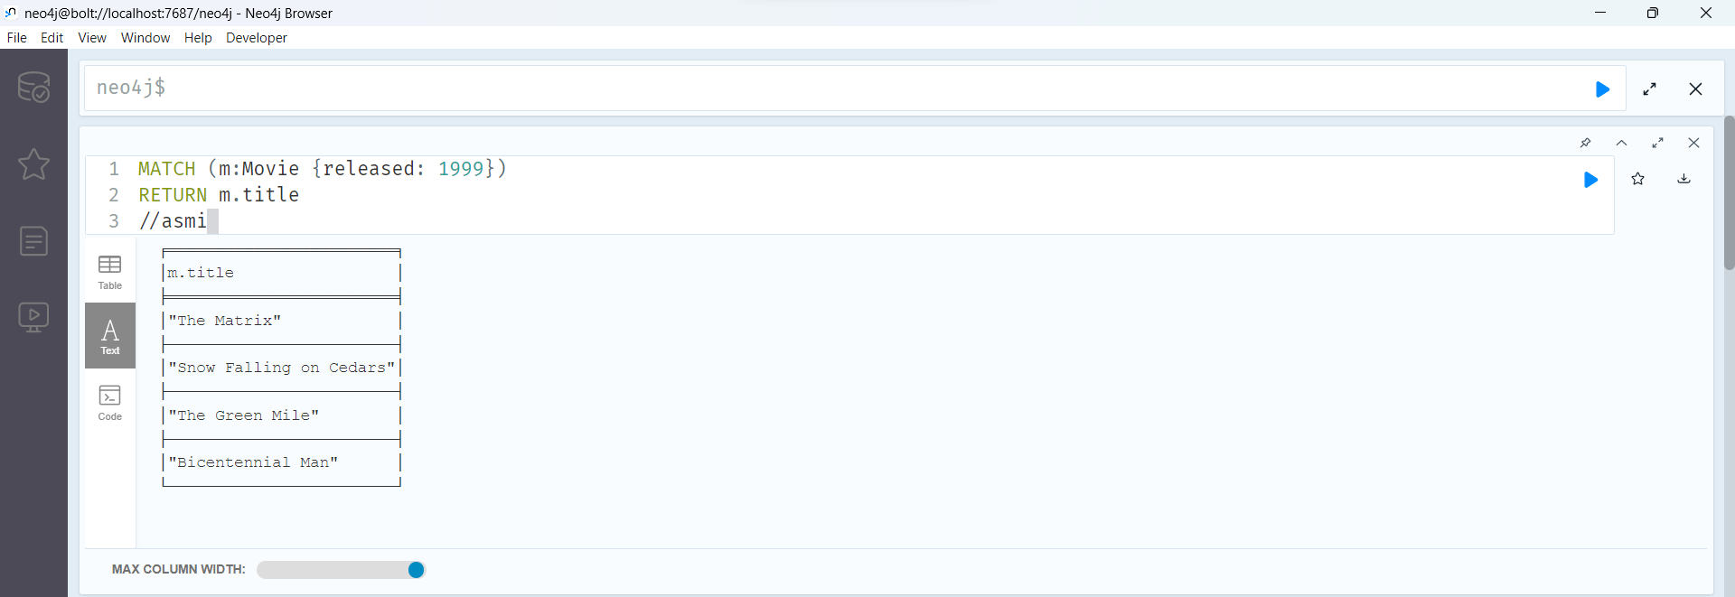

Finding co-actors of a specific actor - “Keanu Reeves”:
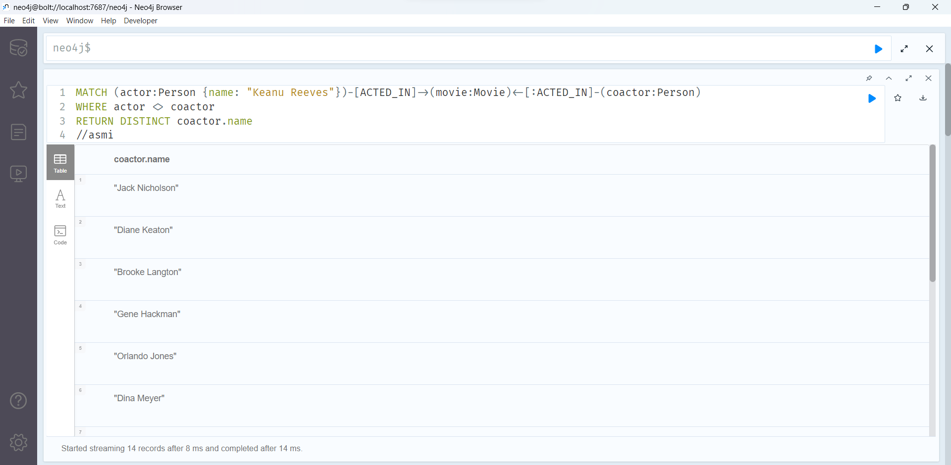

Count number of actors in each movie:
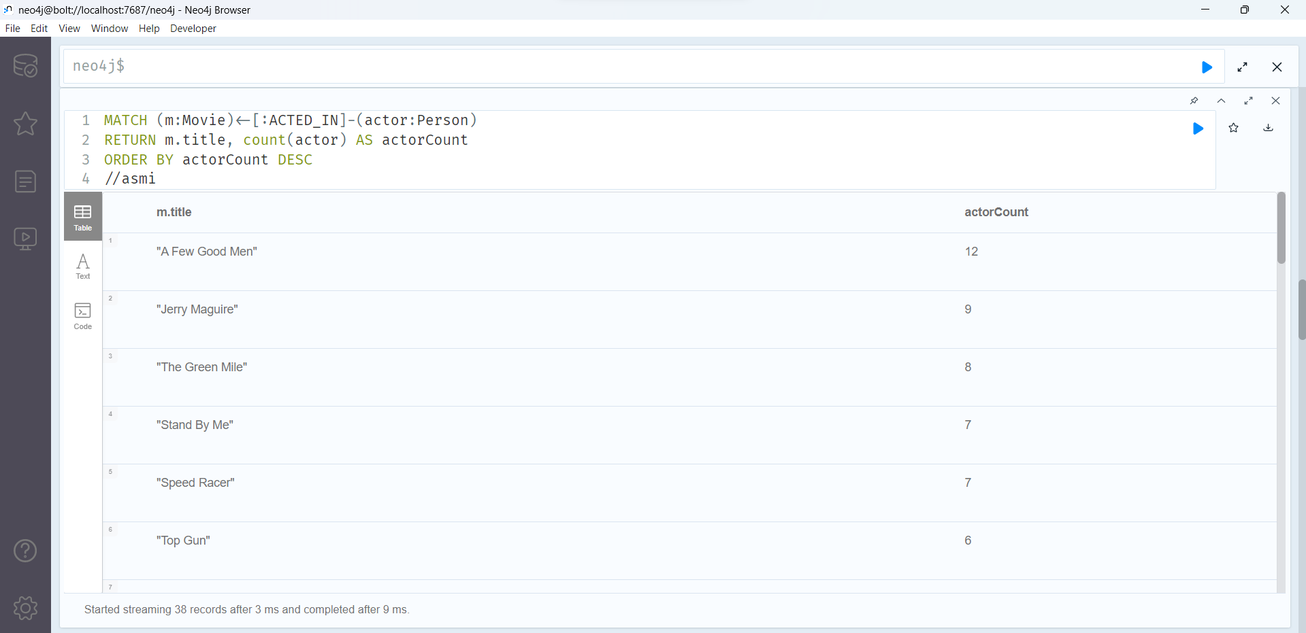

Find actors who worked together on multiple occasions:
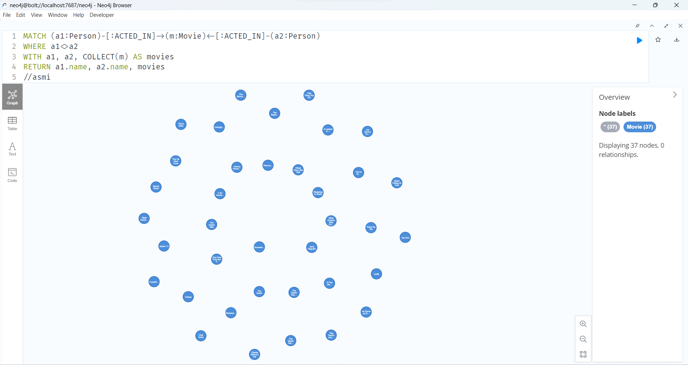

Find common movies between actors:
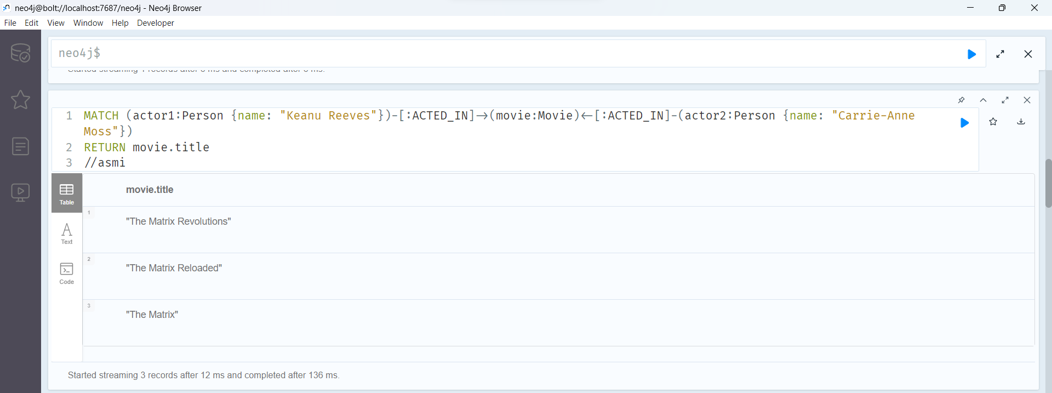

Find all movies directed by a person:
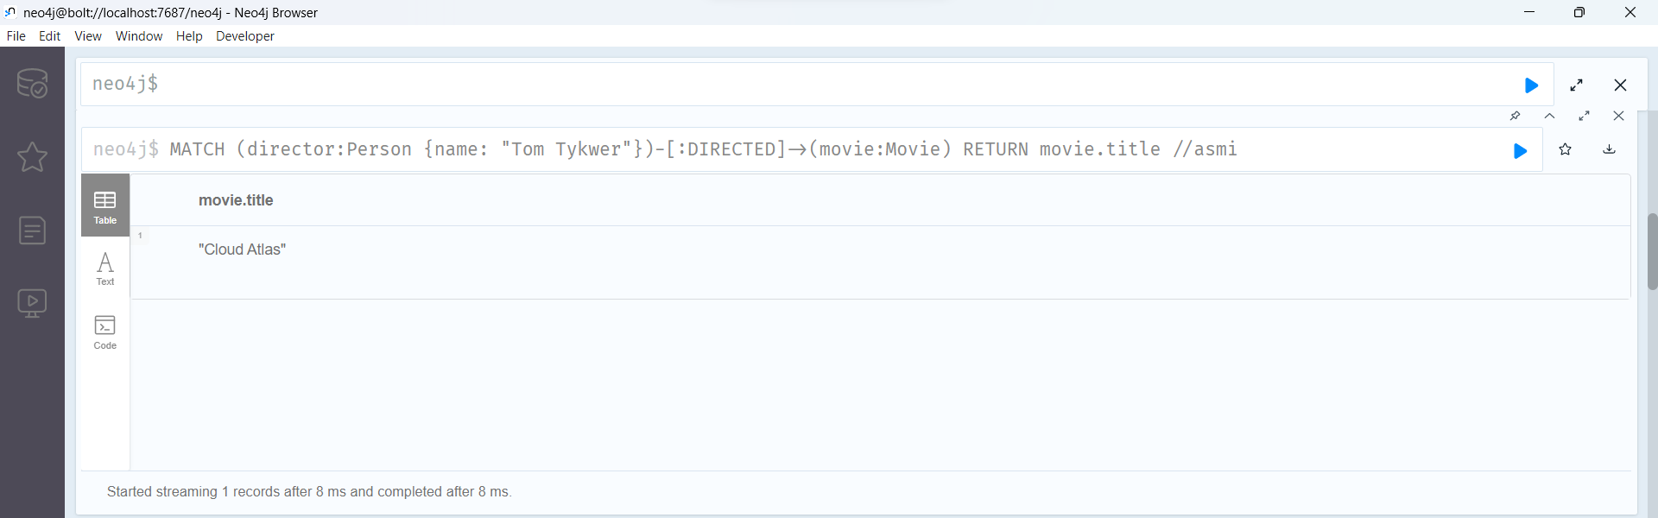

Search for all directors of a movie:
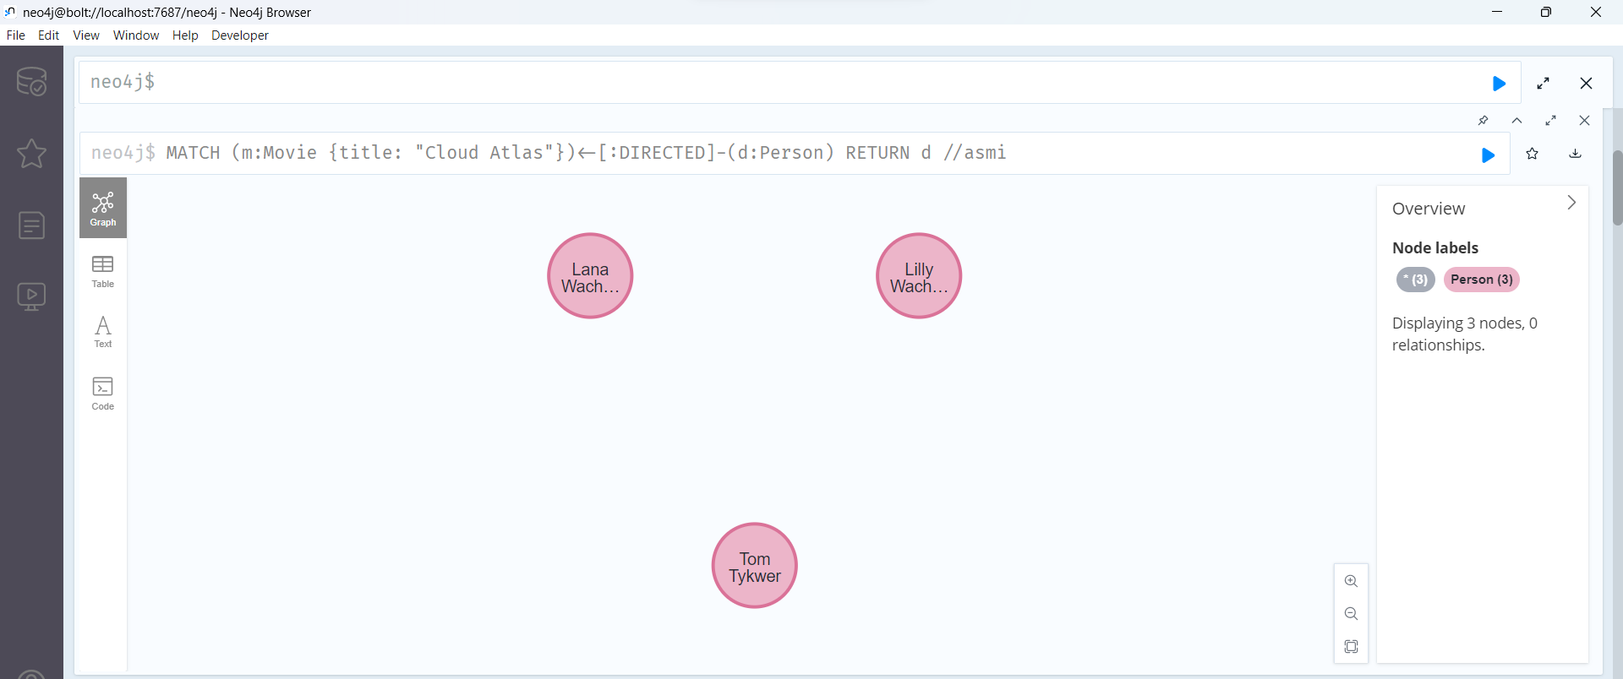

Search for movies based on keywords:
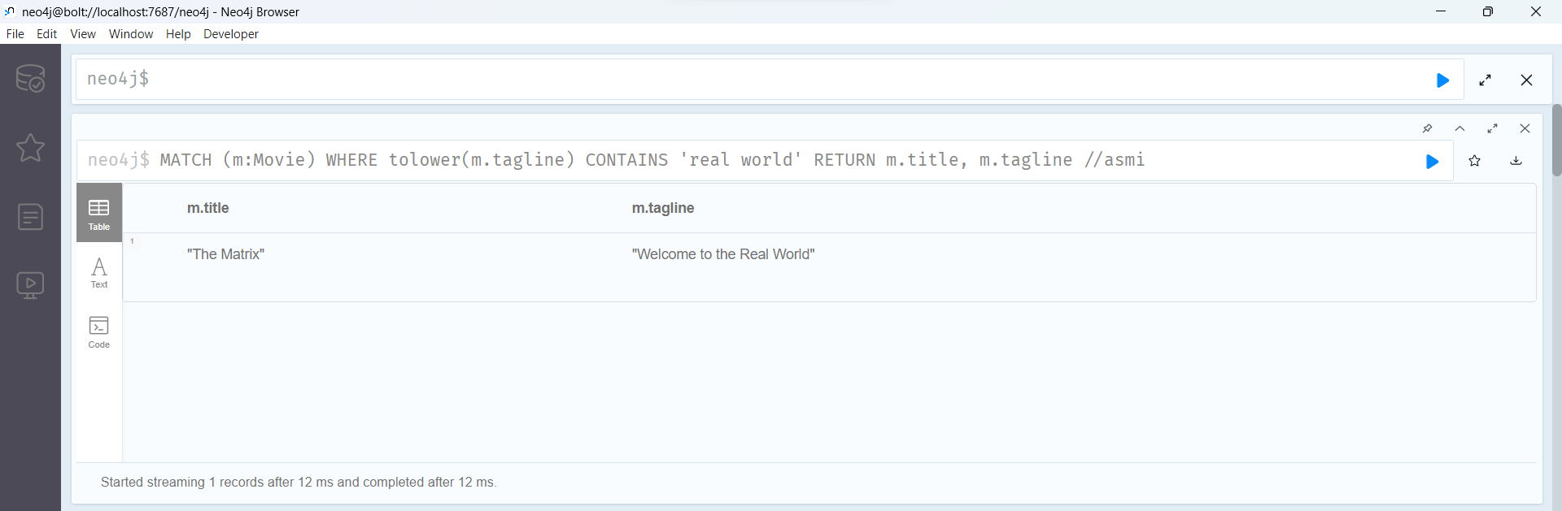

Conclusion:
Successfully performed analysis on a dataset using Neo4J.

